Now Lifestyle SAMPLE Follow up emails FROM DAVE GARDNER

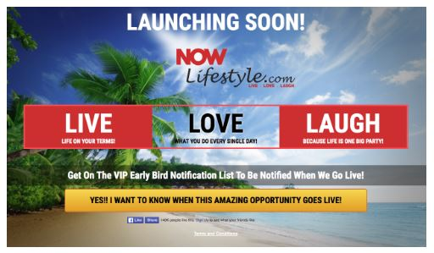
Here is a short series of initial follow up emails that you can MIRROR for your Now Lifestyle Campaign. I would not copy them word for word, though use them as example of how to welcome and present YOUR voice to your Leads...Yes, these are the messages that will go out to those who opt into your Lead Capture pages that Look like:

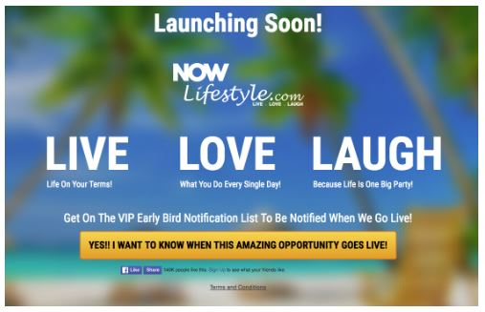

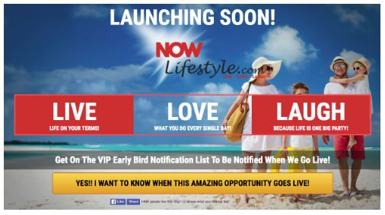

Once they opt in, they will be redirected to the enroll page or the FB Group welcome, but you will be also following up with them through email..Be sure they GET AN INSTANT EMAIL WELCOMING THEM TO NOW LIFESTYLE!
NOTE: BE SURE TO CHANGE ALL LINKS TO YOUR USERNAME
*********************************************************************************
Subject: The Now Lifestyle looks great on you already!
Body:
Just wanted to send a quick hello welcoming you to the Now Lifestyle!
Where Live Laugh Love is the motto to enjoying life longer and better.
I live in YOUR CITY/COUNTRY and am always willing to help whether you have
a question on how the member area works or how to send out your first
message, though the training videos by Joel and the team are always
top notch.
Make sure you have joined the NLS FB group if you have not already
and start interacting and sharing your story.
I\'m here for you so let's make this happen!
If you are really ready to take the next step and enroll, you can be a fast mover
right here with this link:
http://www.nowlifestyle.com/prelaunch/pre_enroll.php?id=USERNAME
YOUR NAME
PS Feel free to call or send me a text at YOUR PHONE NUMBER HERE or reach out to me at Facebook at YOUR FACEBOOK LINK
*********************************************************************************
Message 2
Subject: Did you work it today?
Body:
Whether you worked your muscles or your biz mind, be happy
with your efforts.
One of the best ways to make your efforts more fruitful of course
is being ALL IN as they say so get the full effect of the membership
as well as potential inside being an affiliate.
That means you own all levels level's or membership and qualify
on those levels as well for a better take home...if you know what
I mean.
That means you get to work your gut and your wallet when it come
to being all in with NLS...though if you\'re going to do an actual
workout, make sure it's a quick one as that is the big picture idea
when it comes to high intensity interval training (HIIT) so that you
get it done and can enjoy your life doing other stuff.
Let me know how I can help,
YOUR NAME
YOUR PHONE NUMBER
PS Ready to roll? Just use this link and join the team!
http://www.nowlifestyle.com/prelaunch/pre_enroll.php?id=USERNAME
*********************************************************************************
Message 3
Subject: The Marathon...not the sprint
Body:
Whether you have been in something like the Now Lifestyle or not, it does
without saying that you have to be patient.
It\'s all about the marathon...not the sprint.
While it can be awesome to get people in and enrolled quickly you have to keep
in mind that in most cases you will not become a superstar in a matter of days,
weeks or months...possibly even years.
This is truly where slow and steady wins the race.
Yes, there are some superstars who bring in big teams in a short time, though
they are the minority exception here.
I don't expect you to build out huge any time quickly though I do expect
you to have some patience along the way and realize things take
time.
You have to develop an attractive character with people where they
know, like and trust you...That takes time.
Relationships take time to build, so keep that in mind.
On that note however, you can not make any progress sitting
from the side just being an observer. You have to be a participant
at the same time.
You gotta act and remember that imperfect action beats perfect inaction
every day of the year.
Don\'t wait until an ideal situation arises for you to move forward, or
make your first video, or reach out to your first leads...Do it now!
Live and learn...Fail a little and take that knowledge into the next round!
Come do it now with me and let me help in the process!
http://www.nowlifestyle.com/prelaunch/pre_enroll.php?id=USERNAME
Remember...'someday' does not exist on any calendar!
Do it today!
YOUR NAME
YOUR PHONE NUMBER

*********************************************************************************
Message 4
Subject: Sitting on the Fence (should hurt)
Body:
The other day you opted into one of my capture pages and entered
your name and email to find out more about how you could possibly
shrink your gut and fatten your wallet!
Well it's waiting for you right here with our team:
http://www.nowlifestyle.com/prelaunch/pre_enroll.php?id=USERNAME
Here are some of the perks when you join us...we are hooking you up!
Some of the big ones include:
1) Access to me to help when needed (though the member area will be
top notch and easy to get through if you follow the steps
2) A quick start guide from our upline helping you get up and running in your
first campaign to build leads and be comfortable with your email
autoresponder
3) Access to Coach Seb (from our upline) and his web platform where he
will be hosting webinars in English, Spanish AND French and you get a
coded affiliate link to send people to the room and YOU will get credit
for the signups...even though coach Seb does the live work!
4) Spill over...It is inevitible. With the Binary matrix, our upline have and myself will be giving spill-over and more will come as I know they will want to continue to balance out the 'legs'.
There will be more perks to come, though as they say, you have to be
in it to win it right! So make the right move now and get in on this.
Don't regret a year from now that you kept sitting on that fence as it
will surely hurt deeper the longer you wait.
http://NowLifestyleTeam.com
I'm here for you,
YOUR NAME
YOUR PHONE NUMBER
PS Text preferred, though if you do call, be sure to leave a message.
I get a ton of random phone calls and might not pick up right away
though I will ALWAYS call back if you leave a relevant message.

*********************************************************************************
Message 5
Subject: Call me with your Now Lifestyle Questions
Body:
If you are still curious and not sure about something
that is holding you back from joining the Now Lifestyle,
feel free to give me a call to answer any questions
you might have.
YOUR PHONE NUMBER (OR EMAIL IF OUT OF COUNTRY)
That is my personal phone line (YOUR COUNTRY) and you can
call or text with any questions.
Now as I get a ton of random phone calls for being in
marketing, I most likely will not recognize your number
so be sure to leave a name on your message and I
will get back to you within a couple hours in most cases.
Plain and simple, if you want to be healthy and
be able to bring in some dough at the same point
then you gotta get in.
http://www.nowlifestyle.com/prelaunch/pre_enroll.php?id=USERNAME
You can always reply to this email with questions as well.
I'm here to help!
YOUR NAME

*********************************************************************************
IMPORTANT NOTES:
Be sure to have your first message go out on Day '0' (zero) then you can space them however far apart you want them...I like to send one at least every day for a while.
Keep it generic! If you do not update these often, I would not talk about the weather or any current events (For example don't mention how the New Years eve 2016 party was great, when they could be reading this email in 2018 or later)
Be consistent: Don't just send a couple and never do it again...You have to keep at this.
Be live and current: While the automated follow-ups are nice, you should also be using the "send broadcasts" feature as well to send out current emails...This is where you CAN Talk about what is going on and what the current events are...Depending on when you are reading this you might remember when Joel posted some videos of the power issues they were having on February 21, 2017 due to a Tornado...well I used that and sent an email to my subscribers (see below for another example of a live blast)
Be honest/truthful: Remember you are trying to get your leads to know, like and trust you so that they want to find out more about you and Now Lifestyle

EMAIL BROADCAST EXAMPLE
SUBJECT: Monday Mania...The Tornado Touchdown!
BODY:
Wow...I just got an email from Joel Therien, the CEO from Now Lifestyle
and he said they just had a tornado right near their offices in Texas!
Dang!

They are all safe though and possibly only some slight damage to the outside of their building, though he said the winds were crazy.
That is the cool thing about Joel and this company..If something goes wrong or might be an issue, he is extremely transparent and lets us know about it and keeps us in the loop at all times.

We are a family!

When you join us in the family you will be able to see it yourself too in how much he cares and wants us to succeed.
You gotta be in it though and this week marks the end of Phase one of our Prelaunch and leadership building.

http://www.nowlifestyle.com/prelaunch/pre_enroll.php?id=USERNAME
While Joel was litteraly in the closet during this blast of mother nature, as always he gets back up and is ready to take on the world!
That is what it is all about...Being able to keep getting back up.

We are here to provide leadership and if you have the desire to keep getting back up, then we want you to work with us with the Now Lifestyle.

Just click here==> http://www.nowlifestyle.com/prelaunch/pre_enroll.php?id=USERNAME

Our team is already growing nicely and I want to be able to provide spillover to you in the binary plan we have running as part of the dual comp system!

Those who take action now will het more added to them...just saying!
I'm here to answer any questions so reply to this post and I'll
be sure to get back to you quickly.

Come do this and Live, Love and Laugh with me and the NLS!

YOUR NAME HERE
*********************************************************************************
Be sure that you are editing EVERY Email you swipe or borrow from me here. You are more than willing to use and modify to your hearts content. The more you tweak to relate back to YOU and YOUR story the better.

Remember, YOU are the one building the relationship through your lead capture system emails. While I appreciate people joining my business, I want you to be able to experience the same successes and build your brand and status in the process.

Don't be afraid to let people know a little about you in your emails and be personal, be conversational and be consistent.

Want to learn more about building your Now Lifestyle business?
Be sure to check out the website pages at http://Start-Quick.com
Get updated on new trainings, strategies, marketing tips, quick-start guides and documents, lead generation and much more.
